Purpose: To provide you with the opportunity to gain additional insight into aspects of query performance.
Deliverables: Provide the specified answers and results in the spaces marked below and submit the updated file using BrightSpace. You do not have to demonstrate your work to your lab professor if you have good documentation provided. Your lab professor may request a lab demonstration. The lab exercise is worth 2 marks towards your lab grade if correct and submitted on-time or early.
Activities:
- Logon as sysdba and unlock the SCOTT account. Also change the password of the scott account into “tiger”.
  - From the scott user account:
    - Enter: explain plan for
select ename, dname from emp natural join dept;
Enter: SELECT PLAN_TABLE_OUTPUT
FROM TABLE(DBMS_XPLAN.DISPLAY());
    - In your MS Word submission document, clearly identify the steps that oracle is planning to use in order to execute the query submitted in (1ai) , and paste a screen snapshot of the Explain Plan query and the Plan_Table_Output.
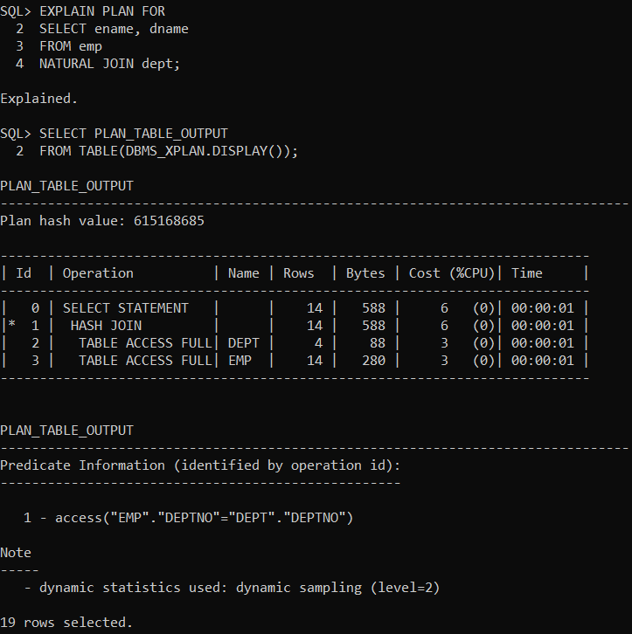

  - This step will require you to investigate the “plustrace” role that allows tracing in realtime. You will Set autotrace ON and re-execute the query in (ai).
    - First, create the plustrace role. The commands required are contained in the plustrc.sql file which is included in the Oracle19c install files. (Mine was located at:D:\Oracle19cinstall\sqlplus\admin)
    - Then, grant the plustrace role to the scott account. Show your work below.
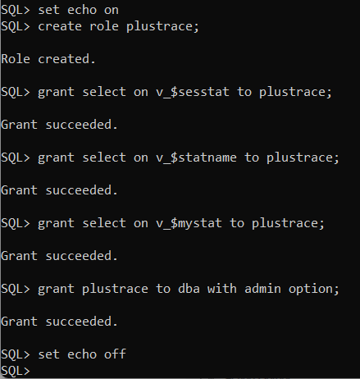
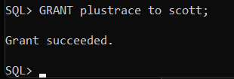
  - Now, execute set autotrace on; and re-generate the explain plan for the query in 1ai. Paste a screen snapshot of Plan_Table_Output .
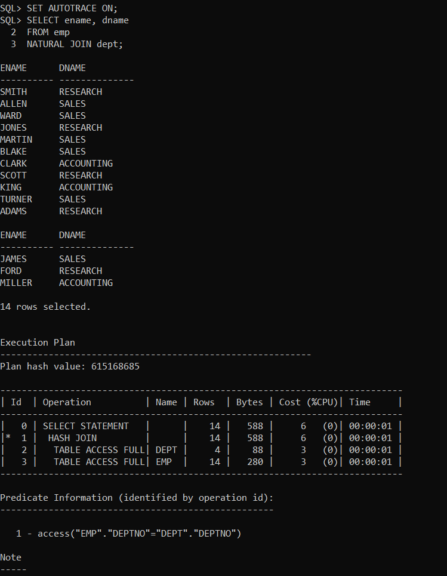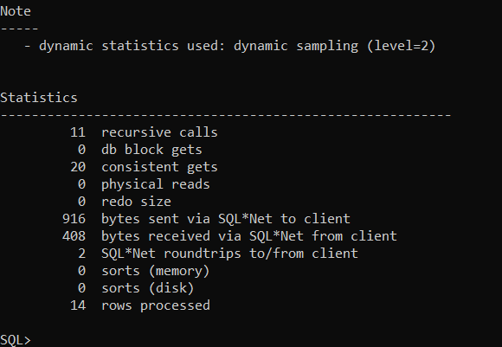

  - Set autotrace OFF. Modify the select statement from 1ai to give Oracle a hint by inserting /*+ gather_plan_statistics */ right after the select word in the select statement.
  - If you add the hint to “gather_plan_statistics”, then Oracle uses the dbmx_xplan.display_cursor to pullout the format information stored in the library cache of the shared pool. You DO NOT have to run the “EXPLAIN PLAN” command explicitly. After you simply just execute the query (i.e., without the prefix “EXPLAIN PLAN FOR ….”) you can use the statement below to show the plan_table_output containing all statistics that are available for the last executed query.
select * from table(dbms_xplan.display_cursor(format =>'allstats last'));
This command gets the statistics for the last query containing the “gather_plan_statistics” hint that was executed by the current user. (There is actually an array of the past entries for which plan statistics have been gathered for the user).

Remember you may need to grant the particular user the right privileges in order to display the information that has been stored in the statistical table. Show all your work to execute the query and then display the statistics output. (There is lots of documentation online – if you are interested, you can look at: https://www.oracle.com/technetwork/database/bi-datawarehousing/twp-bp-for-stats-gather-19c-5324205.pdf )
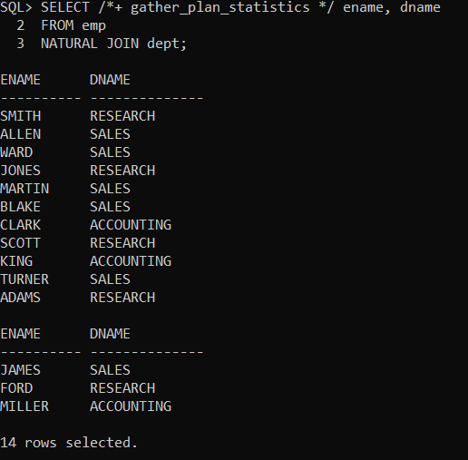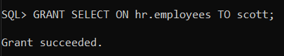
- Index null values:
  - Create an index “commi” on field comm in the emp table. Set autotrace ON, and then run a query to find all the employees where comm is null. Include a screenshot of the explain plan and plan table output.
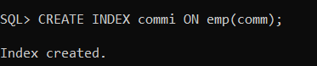
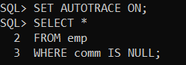
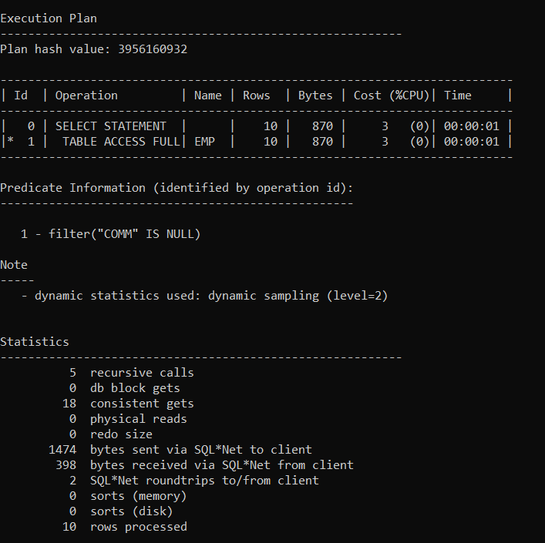

Has oracle used the index commi to answer the above query? Why?
No oracle execution plan shows that scott has full table access in the operation column. I believe this occurred because the column was set to null and so oracle chose to ignore it, making it just use the full scan rather than index that was created.

  - Drop the index commi, and then create another index on the same field with the same name but with a slightly different structure.
Create index commi on emp(comm, 1);
Run the same query again as in part 2a. Include a screenshot of the explain plan and plan table output.
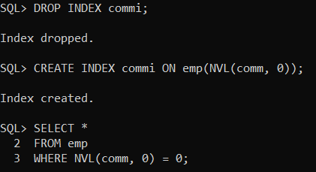
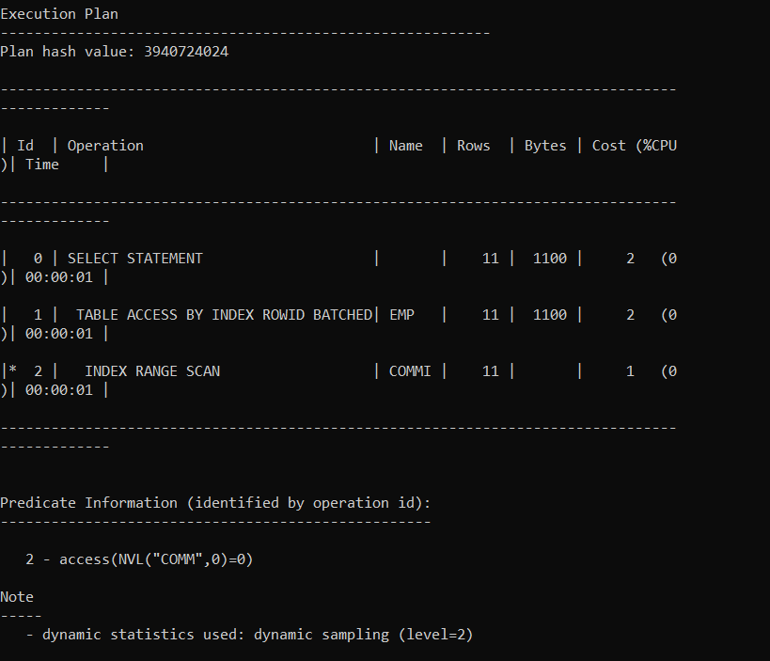
Has oracle used the index commi to answer the above query? Why?
Yes oracle used the index commi this time. The select quest is now specified to locate and handle the commi row that is null.

- Index wildcards %:
  - Now we will work on the dept table. Create an index on the LOC field. Write a query that finds all the departments having their location starts with “NEW”. Include a screenshot of the explain plan and plan table output. Has oracle used the index to answer the query?
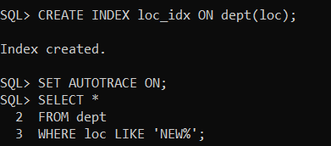
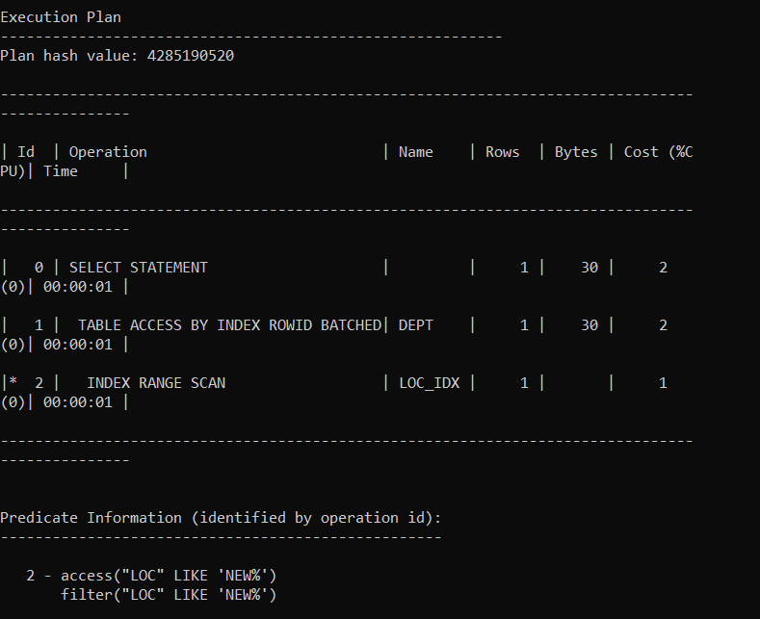
- Write a query that finds all the departments having their location includes the word “YORK”. Include a screenshot of the explain plan and plan table output. Has oracle used the index to answer the query?
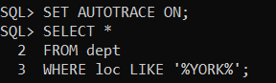
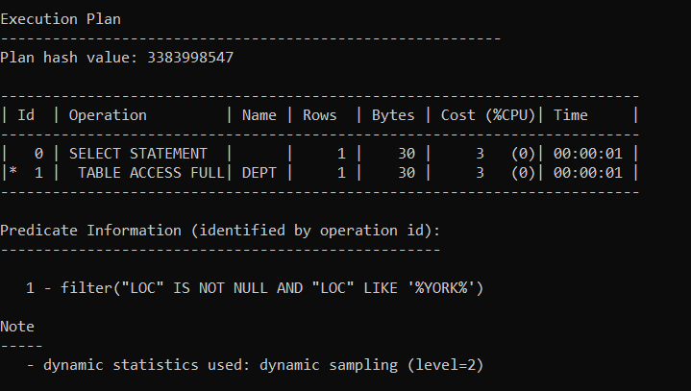

No, oracle has not used the index to answer the query, it chose to do a full table search instead.
  - Create another index with different structure on the loc field.
Create index locctx on dept(loc) indextype is ctxsys.context;
Include a screenshot of the explain plan and plan table output for the following slightly changed from the above query?
Select * from dept where contains(loc, ‘YORK’) > 0;
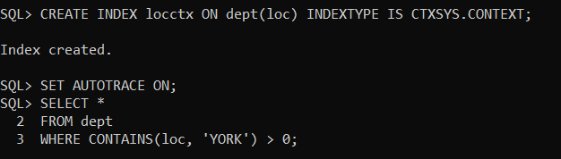
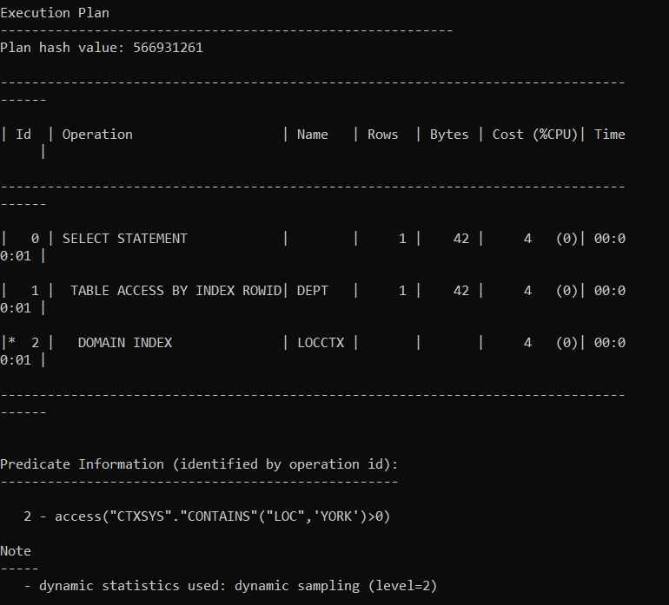

Has oracle used the index locctx

Yes, with the corrected index, oracle has now been able to use the index.

- When Indexing is good?
  - Set autotrace off; and then Set timing on;.
Then, create two tables t1 and t2 as follows:
Create table t1(c1 varchar2(10));
Create table t2(c1 varchar2(10));

  - Run the below query to insert 1 million records into the table t1
insert into t1 select 'king' from dual connect by level < 1000000;
Take note of the time needed to insert into the table t1.
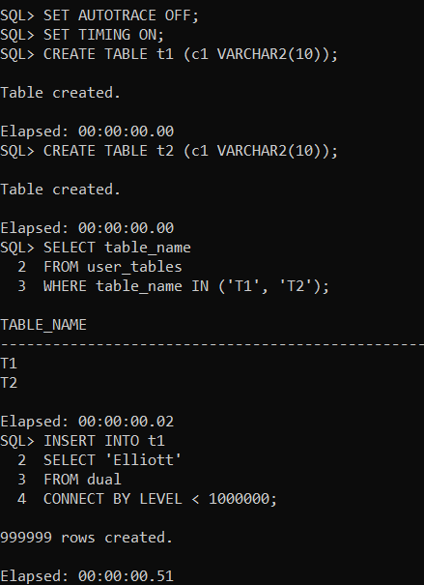
  - Now create an index on field c1 in the t2 table and then insert one million records to t2. Compare the two running times. Do you think indexing is good all the time?
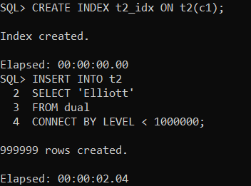
The time to insert was significantly longer than in t1, which in the case of mass data uploading could be quite harmful to the speed in which it is processed.
  - Give a real-life situation where an index could/should be created after inserting data rather than before inserting data.
A very common scenario that indexing should absolutely be used is when uploading bulk data into a database or data warehouse. Having too many indexes in place could significantly increase the amount of time required to upload the data. It only makes sense to focus on improving query performance once the data is fully uploaded.
You're finished. Please submit.

